Please send this form (by e-mail or post) to the address below.
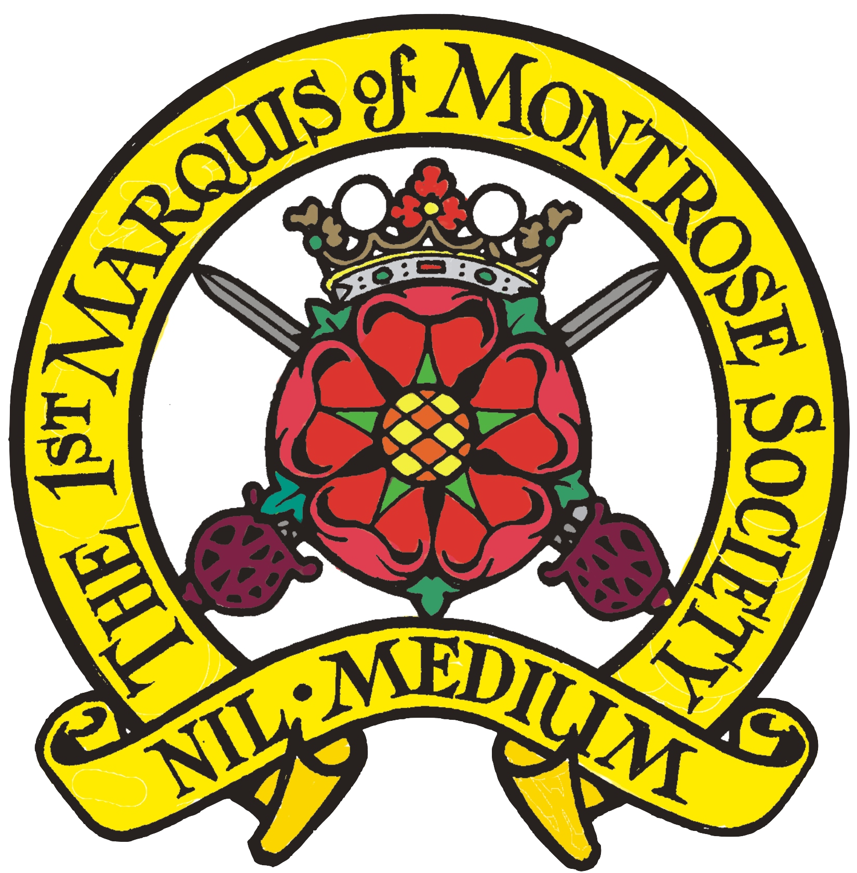

1st Marquis of Montrose Society

Membership Application
Mr/Mrs/Miss/Title _________________________________________________________________
Name _________________________________________________________________
Address _________________________________________________________________
____________________________________________________________
Post Code _______________Tel. No _________________
Email Address ______________________________________________________
Subscription Enclosed £_____________ Cash/Cheque/MO/PO. Etc
Full Membership £20 (Sterling) per annum.
Joint Membership £30 (Sterling) per annum
Junior Membership (Up to 18 years) £5 (Sterling) per annum.
Overseas Membership £20 (Sterling) per annum.

Note – all cheques in GB Pounds Sterling or add $7.00 to cover bank charges.

If paying by PayPal, please use our PayPal e-mail address below (not forgetting to give your name as a reference).

PayPal Address: MarquisMontrose1@aol.com
Membership is from January 1st to January 1st
Please return this form (by e-mail or post) with your remittance (in UK pounds), made payable to '1st Marquis of Montrose Society' to:
James Hair
23 Rose Street
Thurso
Caithness, Scotland KW14 7HN
Email: jshdne@aol.com
Data Protection: Information held on computer will only be made available to other 1st Marquis of Montrose Society members. All members will allow their details to be held on computer unless they specifically request otherwise.

